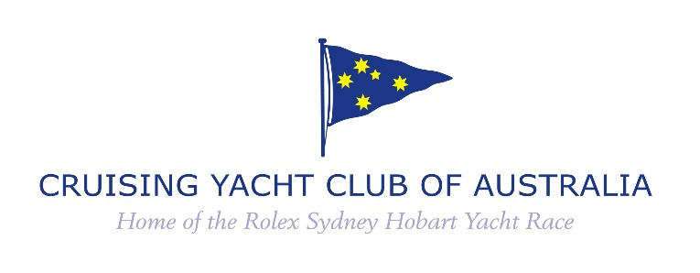

78th ANNUAL GENERAL MEETING

ELECTION OF FLAG OFFICERS AND DIRECTORS
TUESDAY 12 JULY 2022

NOTICE PURSUANT TO CLAUSE 6.4 CYCA CONSTITUTION

INVITATION TO NOMINATE

Any two Voting members may, with the consent of their nominee, nominate an eligible person as a candidate for election to office for the ensuing year.

- To nominate a candidate, the Voting member must be a Full Member, Life Member or Country Member in “good financial standing”;
- “good financial standing” means that the member at the time of nomination has no annual subscription fees or other moneys payable by that member to the Club in arrears by more than two months (unless the Board has allowed a longer period in special circumstances);
- The candidate must be a Voting member (as defined in paragraph 1 above) for not less than one year;
- The Commodore, Vice Commodore and at least one Rear Commodore must be a Yacht Owning member (as defined in Clause 1.5 of the Constitution);
- Immediately following the appointments, not less than one half of the Directors or, if their number is not a multiple of two, the number nearest to but not less than one half, are Yacht Owning members.

IN ACCORDANCE WITH CLAUSE 6.4 OF THE CONSTITUTION NOMINATIONS MUST BE LODGED IN WRITING WITH THE SECRETARY OF THE CLUB (JUSTINE KIRKJIAN) BEFORE 5.00PM ON TUESDAY 28 JUNE 2022. The original should either be handed or posted to the Secretary, or a scanned copy emailed to secretary@cyca.com.au. Note however that if the post is delayed or if the email is not received by the due date due to transmission issues, it cannot be subsequently accepted.

Please see over for the nomination form.

To: The Secretary
Cruising Yacht Club of Australia
1 New Beach Road, DARLING POINT NSW 2027

NOMINATION OF FLAG OFFICERS AND DIRECTORS
2022 AGM

We, the undersigned proposer and seconder, being duly qualified in accordance with the Constitution of the Cruising Yacht Club of Australia, hereby nominate as a candidate for election for the ensuing year:

Name Membership No.

Address
(Cross out any inapplicable categories below. If the candidate is nominated for more than one category, upon the nominee being elected to the most senior appointment, the nominations for any other categories shall lapse.)

As: Commodore
Vice-Commodore
Rear-Commodore
Treasurer
Director

Is the candidate a ‘Yacht Owning member’ as defined in Clause 1.5 of the Constitution?

If so, name of yacht

Proposer's signature Membership No.

Seconder's signature Membership No:

Date

I consent to the above nomination and confirm that:
- I am not ineligible to be appointed to the Board of CYCA as a consequence of a declaration under section 57H(2) of the Registered Clubs Act 1976 (NSW);
- no declaration has been made under section 57H(2)(g) of the Registered Clubs Act 1976 (NSW) that in any previous period I was ineligible to be appointed to be appointed to the Board or as Secretary of CYCA or any other registered club;
- as a consequence of declaration(s) made under section 57H(2)(g) of the Registered Clubs Act 1976 (NSW) I was ineligible to be appointed to be appointed to the Board or as Secretary of CYCA or another registered club in the following previous periods(s): _______________________
(Delete whichever of 2 or 3 is inapplicable)

(Nominee's signature)

Official Use only: Time and Date received:

Received By:

